*Revised July 2016*

**Demand Survey Form for**

**Knowledge Sharing Program (KSP)**

|  |
| --- |
| * *This proposal aims to collect relevant information that will be used to identify the specific agenda for the Knowledge Sharing Program (KSP) and the expertise required.* * *Full and accurate completion of this form will help facilitate the selection of appropriate research and consultation agenda for the program.* * *Please be aware that, this form must be submitted no later than Oct. 31st of this year for the consequent pre-feasibility review process, which is mandatory procedure to be eligible for KSP.* |

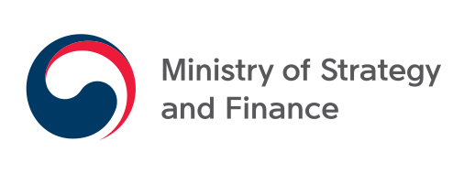

|  |
| --- |
| **Guideline for Writing KSP Demand Survey Form** |

The partner country is requested to fill in all the blanks in detail to be reviewed by the Korean Government. The partner country will be chosen based on the contents of this particular ‘Demand Survey.’ The partner country is to submit the form to the Korean MOSF via **official** **diplomatic channel no later than October 31st of this year**.

**INSTRUCTIONS:**

**A. Description of the Organization Suggesting the Project (See page 4)**

* **Project Supervisor**: One local project supervisor, in charge of the entire project, i.e. one senior official in charge of supervision of all activities within the framework of the KSP, local experts, responsible for the role of the counterpart organization, etc.
* **Program Coordinator (Policy Practitioner)**: One local program coordinator who will serve as the focal point to communicate with the Korean counterpart. The contact person will work one-on-one with the Korean counterpart in matters such as arranging the meetings, and organizing seminars and workshops in the partner country.

**B. Description of the Suggested Project (See page 5)**

* **I. Types of cooperation for each topic**: The main topic and three or four sub-topics must be identified in line with each other. For the main topic, the types of approach must be indicated. The different types of cooperation are suggested as follow:
* **(1) Policy Consultation (Practitioner’s Workshop included)**: Policy consultation carries out collaborative research, training, consultation according to the program cycle.(For more detailed information, refer to Appendix II)
* **(2) Practitioner’s Workshop Only**: Capacity building workshop provides capacity-building and training on technical and hands-on knowledge of relevant Korean experience for policymakers or practitioners of the partner countries. Workshop on capacity building can take place either in Korea or in partner country for a week.
* **(3) Dispatch of a Policy Advisor**: Korean expert(s) can be dispatched to a partner country for in-depth, practical and theoretical policy consultation to implement policy recommendations. The period of stay of an expert will vary from one to six months.

Based on the demand survey forms collected through diplomatic channels, research topics are chosen by the feasibility review committee and Ministry of Strategy and Finance (MOSF). Proposed topics are reviewed based on the policy priorities of the partner countries, strategic importance to Republic of Korea, and the applicability of Korea’s experience and expertise to the topic. Please be understood that the Korean government is not able to accommodate all topics received due to limited resources.

**C. Submitting the Demand Survey Form**

*After writing the demand survey form, please follow the submission process below.*

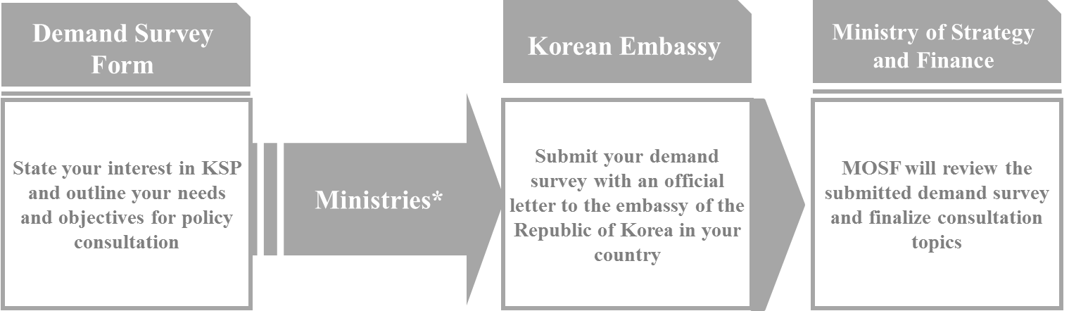

*\* Submit to ministries in charge of foreign affairs or official development assistance (ODA).*

***A. Description of the Organization Suggesting the Project*** *(For instruction, please refer to page 2)*

|  |  |
| --- | --- |
| 1. Organization name: |  |
| 2. Address:  Online Website: |  |
| 3. Project Supervisor:  (Name)  (Position & Department)  (Tel)  (E-mail) |  |
| 4. Program Coordinator[1]  (Name)  (Position & Department)  (Tel)  (E-mail) |  |
| 5. Brief introduction of the organization |  |

***B. Description of the suggested project***

**I. Project Outline**

*Please write the topic and three to four sub-topics for this project. Also check the type of cooperation that your government would like to take.*

**Topic:**

**Sub-topics:**

**1)**

**2)**

**3)**

**4)**

|  |
| --- |
| **Types of Cooperation:**  Policy consultation  Practitioner’s capacity building workshop  Dispatch of a policy advisor |

**II. Background (topic or sub-topics)**

*This part can be explained by the topic as a whole or by individual sub- topics.*

***(1) Current status and problems***

*Explain the background of this project’s topic or the sub-topics. Please state the current status using factual information and the problems that this project will address.*

|  |
| --- |
|  |

***(2) Relevant policy documents***

*Please give brief description of related official documents (e.g. national development plan).*

|  |
| --- |
|  |

***(3) Relevant international cooperation projects***

*Please give brief description of assistance programs from other countries or international organizations in the related fields (e.g. name of the project, etc.)*

|  |
| --- |
|  |

**III. Specification of the Suggested Project**

***(1) Objective(s)***

*Provide the objective(s) of this project and how this consultation or cooperation will be in line with relevant thematic priorities in your country.*

|  |
| --- |
|  |

***(2) Contents expected from Korean experts***

*Explain in detail the contents expected from Korean experts. Please provide a Terms-of-Reference for the Korean expert, if possible.*

|  |
| --- |
|  |

***(3) Expected outcome(s)***

*Describe briefly the expected outcome(s) of the topic or each sub-topic.*

|  |
| --- |
|  |

**IV. Plans on Utilizing KSP Recommendations**

*Explain how your government plans to utilize the consultation report or other cooperation outputs of this project. Please check the box below and describe in detail potential linkages and other collaborations in terms of domestic and international perspective, if any is intended.*

1. ***Domestic***

|  |
| --- |
| Institutional building  Establishment of organization  Legislation of law, regulation or decree  Financial procurement/budget allocation  Policy learning /capacity building  Others (Please specify:       )  *Please describe in detail if you checked any of the above.* |

1. ***International***

|  |
| --- |
| Development of official development assistance projects with Korean agencies  Development of projects with international organizations (e.g. Multilateral Development Banks)  Expansion of business opportunities with Korean companies  Cooperation with related Korean institutions for exchange projects (MOU)  Promotion of partnership with NGOs or private sector  Others (Please specify:       )  *Please describe in detail if you checked any of the above.*  ­ |

**V. Other Requests**

*Briefly state if there are other requests not mentioned above.*

|  |
| --- |
|  |

|  |  |
| --- | --- |
| (Name and Position of Project Supervisor) | |
| MM/DD/YYYY  (Date) | ________________________  (Signature) |

***Coordinating Ministry/Institute ONLY***

**Priority List of Demand Survey for Knowledge Sharing Program**

The coordinating counterpart ministry/institute is requested to review the *Demand Survey Forms* submitted by the partner country. The coordinating ministry/institute should list the topics in the order of priority which will then be taken into consideration for the Knowledge Sharing Program.

Once this form is filled, please attach the *Demand Survey Forms* and send them to the Ministry of Strategy and Finance in Republic of Korea through the official Korean diplomatic channel.

|  |  |  |
| --- | --- | --- |
| **Priority** | **Requesting Organization** | **Requested Topics** |
| 1 |  |  |
| 2 |  |  |
| 3 |  |  |
| 4 |  |  |
| 5 |  |  |
| 6 |  |  |
| Cont. |  |  |

|  |  |
| --- | --- |
| (Counterpart Agency) | (Contact Person: Title/Name) |
| MM/DD/YYYY  (Date) | ________________________  (Signature) |

|  |
| --- |
| **APPENDIX I. INTRODUCTION TO KNOWLEDGE SHARING PROGRAM** |

In keeping with the global recognition of knowledge as a vehicle for effective development policy as well as based on its own experience of learning from advanced economies, Korea has actively advocated knowledge sharing in its development cooperation endeavors.

Over the past years, the Ministry of Strategy and Finance (MOSF) of the Republic of Korea (hereafter Korea) has played a leading role in the advancement of the domestic economy and establishment of growth dynamics. Having accumulated such remarkable experiences and know-how that triggered rapid socio-economic growth of Korea within just a half century, MOSF saw the need to share its development experiences and know-how with its partner countries. As a result, Knowledge Sharing Program (KSP) was launched by MOSF in 2004.

As a comprehensive policy consultation program, KSP aims to share Korea’s development experiences with the partner countries to promote sustainable socio-economic development. However, KSP’s intent is to not offer any definitive solution or recipes to address specific development issues. Instead, it seeks to analyze the challenges and obstacles of the partner country from the demand-side perspective and provide practical and useful policy alternatives and references based on similar cases and experiences of Korea by integrating policy research, development consultation, human and institutional capacity building. Since 2004, KSP has been conducted for 860 research topics in 55 countries around the world.

1. **Objective**

The objectives of KSP are as follows:

1. Seek practical and useful Korean development experiences for current and ongoing policy issues of the partner countries and put forth concrete recommendations to apply theory-based knowledge into actual situational solutions;
2. Assist implementation of KSP policy recommendations by enhancing government officials’ capacity to manage, formulate and build institutions in policy-related areas via various consultative activities;
3. Foster mutually beneficial relationships through tangible and functional approaches to support partner countries’ economic development efforts.
4. **Characteristics**

The characteristics of KSP are as follows:

1. **Demand-driven Consultation**

In general, the project topics and activities are selected according to the needs and requests from the partner countries, which are tailored to meet the development objectives.

1. **Policy-Oriented Consultation**

The overarching goal of KSP is to provide policy recommendations and alternatives to achieve the development goals of the partner country. Consistent with its goal, it therefore aims to provide concrete policy solutions to the topics selected by partner countries.

1. **Participation-oriented Consultation**

Private sector and public sector experts from both Korea and partner country carry out joint research into topics of their choice and provide policy recommendations to the government of the partner country.

1. **Integrated Consultation**

The KSP is composed of policy research, consultation and capacity building. It aims to promote and enhance policy formulation and implementation capacities of partner countries as well as strengthen the capacity of government officials to formulate policies.

1. **Program Areas**

KSP focuses on areas where Korea has had success and possess strong expertise that can be shared with partner countries. These areas include Socio-Economic Development Strategy, Economic Crisis Management, Financial Services, Human Resource Development, Export Promotion, Knowledge-based Economy, Energy and Green Growth, and Infrastructure Development.

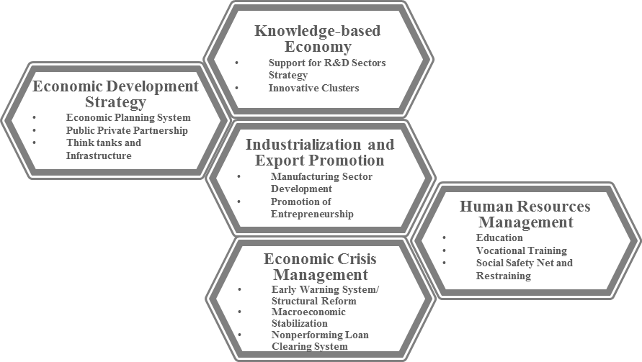

Various other topics/issues in the field of socio-economic development are considered upon request by partner countries. For example, KSP has been implemented in areas such as, *“Enhancing the Consumer Credit Market”* (2006, Algeria), *“WTO Accession Strategies”* (2007, Azerbaijan), *“Building the Basis of SME Development”* (2007, Ghana), *“National Technology and Innovation System”* (2008, Turkey), *“Navoi Free Industrial Economic Zone”* (2009, Uzbekistan), *“Electric Power Generation and Distribution”* (2009, Dominican Republic), *“Energy Efficiency Promotion”* (2009, Ukraine) and *“Establishment of the Vietnam Development Bank*” (2011, Vietnam), “*Strengthening Capacity on Policy Analysis for Myanmar's Economic Development: Establishing Myanmar Development Institute (MDI)”*(2013, Myanmar), *Modernization of Deposit Insurance System in Tanzania*”(2013, Tanzania)

In order to increase access to the remarkable developmental experiences of Korea, MOSF saw a need to systematize and modularize the developmental experiences of Korea and thus began the “Modularization projects. Project proposals based on Modularization topics are welcome for consideration. (see *Appendix III. List of Core Modularization Projects*)

|  |
| --- |
| **APPENDIX II. KSP POLICY CONSULTATION** |

The KSP is a knowledge-intensive development cooperation program with the purpose of sharing Korea’s development experiences with partner countries. The KSP aims to offer comprehensive policy consultations tailored to the needs of partner countries of which the scope ranges from in-depth analysis to policy consultation and to training opportunities.

1. **Program Cycle of the KSP**

|  |  |
| --- | --- |
| **Program** | **Main Objectives and Activities** |
| **1) High-level Demand Survey and Pilot Study**  (in partner country) | **□ Objectives**  ▪ To identify development policy priorities of the partner country  ▪ To decide specific topics through interviews and surveys  ▪ To identify counterpart organizations and Local Consultants  **□ Activities**  ▪ The Korean experts will visit the partner country to collect relevant data and information and to finalize the research topics by conducting interviews and visiting relevant organizations.  ▪ The most suitable counterpart organization will be selected to cooperate in the KSP.  ▪ Appropriate experts from the partner country will be recruited as Local Consultants for each of the research topic. |
| **2) Additional Pilot Study**  (in partner country) | **□ Objectives**  ▪ To collect additionally required information and data  **□ Activities**  ▪ The Korean delegation may visit relevant organizations and sites in the partner country in order to gain in-depth analysis on the situation of the partner country and meet with relevant experts who will share their knowledge on the research topics. |
| **3) Interim Reporting Workshop and Policy Practitioners’ Workshop**  (in Korea) | **□ Objectives**  ▪ To invite the policy practitioners, high-ranking government officials, policymakers from the partner country to Korea to share the tentative final policy recommendations  ▪ To gain feedback and comments to update the interim report.  ▪ To visit relevant organizations for first hand experiences.  **□ Activities**  ▪ The experts from the partner country will be invited to Korea to give their comments and views on the interim report of final policy recommendations.  ▪ The delegation will meet with Korean policymakers and relevant experts who will share their knowledge relevant to the research topics as a form of policy training.  ▪ The delegation may visit relevant Korean organizations and sites, including Government Ministries, industrial sites, business organizations and companies in order to gain on-site observation of Korea’s experiences. |
| **4) Senior Policy Dialogue and Final Reporting Workshop**  (in partner country) | **□ Objectives**  ▪ To present the final policy recommendation paper to relevant top policy makers and various stakeholders  **□ Activities**  ▪ Senior Policy Dialogue will be conducted between policymakers of both countries in order to share the final policy recommendations.  ▪ Various stakeholders and opinion leaders, including from the government, private sector, academia, and media will be invited to the Final Reporting Workshop, where the Korean experts will present their final policy recommendations.  ▪ Evaluation interviews are to be conducted to assess relevancy and sustainability of the recommendation and to build upon possible follow up programs. |
| **5) Dissemination Seminar**  (in Korea) | **□ Objectives**  ▪ To share the main policy points of the KSP recommendations in Korea with other opinion leaders and stakeholders  **□ Activities**  ▪ An annual Dissemination Seminar will be organized to share the research outcomes and main policy points of the KSP conducted throughout the project period of a year.  ▪ The final reports of each KSP project will be distributed.  ▪ Korea experts and local experts may be kindly asked to present their projects. |

1. **Role of the Partner Country**

As an intergovernmental program, close cooperation and collaboration among counterpart is a crucial element in achieving the expected outcome of the KSP.

1. **Recommendation of Local Consultant**

The counterpart organization of the partner country must recommend and select local consultants in the field of specific sub-topics of the project. The scope of work between the local consultant and the Korean experts are as follows:

* Local consultants are required to (i) provide relevant data and information for effective research, (ii) fulfill the role of co-author of the final report on case-by-case issues, and (iii) cooperate with the Korean experts in all possible means for the completion of the report.
* The Korean experts will primarily assume responsibilities related to studies on the Korean experience while local experts will assume responsibilities related to studies on the challenges the partner country is facing.
* Recommendations on methods to apply the Korean experiences to address the problems of partner countries on focused areas will be made jointly by experts from both countries, if possible.

1. **In-kind Contribution**

The Korean Government may consider bearing all direct costs arising from activities described in the Project Cycle above. However, costs will be shared with the counterpart organization for non-official development assistance (ODA) partner countries[2] and ODA partner countries if necessary.

The counterpart organization of the partner country is required to make any necessary in-kind contributions within its capacity (e.g. provision of office space, computer facilities, interpretation, etc.) to coordinate the visit of Korean experts to partner country during any stage of the project cycle.

Details are to be stipulated in the Memorandum of Understanding (MOU) and Activity Agreement between two counterpart organizations.

1. **Meeting Arrangements and Seminar Preparations**

In the process of carrying out the project cycle within the partner country, the counterpart organization is responsible for:

* Arranging meetings with senior government officials and experts in the field of study upon request of the Korean experts; and
* Organizing seminars and workshops, including logistical supports.

1. **Recommendation and Organization of the Country Delegation**

The local counterpart organization is responsible for making recommendations and organizing its delegation that will visit Korea once or twice: and also for the Interim Reporting and Policy Practitioners Workshop.

|  |
| --- |
| **APPENDIX III. LIST OF CORE MODULARIZATION PROJECTS[3]** |

|  |  |  |
| --- | --- | --- |
| **Areas** | **Title** | **Author** |
| Economic Policy | Public Investment Management Reform in Korea:  Efforts for Enhancing Efficiency and Sustainability of Public Expenditure | Jay-Hyung Kim |
| Public–Private Partnerships: Lessons from Korea on Institutional Arrangements and Performance | Jay-Hyung Kim |
| Performance Management System of Budgetary Programs in Korea | Chang Gyun Park |
| Korea's Capital Market Promotion Policies : IPO and Secondary Market Policy Experiences | Woochan Kim |
| Industrial Development | Establishment of Free Export Zones | DoHoon Kim |
| Introduction to the Export-Import Bank of Korea:  Implications on the Establishment and Operation of an Export Credit Agency | Seung-ho Sohn |
| Establishment of a Trade Promotion Organization(TPO) | Youn-Soo Rah |
| Establishment and Roles of Industrial Bank of Korea | Jeong Yun Lee  Bokwang Kim |
| Establishment of Korea Credit Guarantee Fund and Its Operation | Yongju Chin  Hyo-Eui Kim |
| Rural Electrification Project for Expansion of Power Supply | Sung Woo Lee |
| Governance of SOEs and Public Institutions in Korea | IlChong Nam |
| Agricultural Policy | Saemaul Undong (New Village Movement) and its Best Practice Cases | Do Hyun Han |
| Land Reform in Korea | Myung Ho Park |
| White Revolution of Agriculture in Korea: The Achievement of Year-round Production and Distribution of Horticultural Crops by the Expansion of Greenhouse Cultivation | Hyo Duk Seo |
| Policy for Promotion of Agricultural Mechanization and Technology Development | Jin Ha Yun |

|  |  |  |  |
| --- | --- | --- | --- |
| Health and Medicine | The Operation of Nationwide Health Insurance and its Implications | | Jin Soo Kim |
| Healthcare Improvement Activities of Public Health Center in Rural Area | | Yong Ae Shin |
| Medical Professional Retraining Program | | Jwa-Seop Shin |
| Sustained National Deworming Campaign in South Korea 1969-1995 | | Taejong Kim |
| Human Resources | Vocational Training System for a Skilled Workforce | | Young-Sun Ra |
| Role and Function of the National Technical Qualification System in the Development of Vocational Ability | | Jae Hyun Park |
| Analysis on Development and Achievement of Compulsory Elementary Education after the Korean War | | Jong-hyeok Yoon |
| Research & Development | Cultivation of Highly Capable Scientists and Engineers Mainly at the KAIST | Yongsoo Hwang |
| Establishment and Management of Government-funded Research Institutes Beginning with the KIST |
| Establishment and Operation of the Daedeok Innopolis Special District |
| The Internalization of Science and Technology in the earlier stage of Economic Development in South Korea | | Sung Joo Hong |
| In-Service Training Policy in Korea | | Kye Woo Lee |
| Land Development | Policy for the Construction and Supply of Affordable Housing in Korea | | Chungyu Park |
| Establishment of Intelligent Transport Systems (ITS) | | Seung-hwan Lee |
| Environment | Volume-based Waste Fee system in Korea | | Kwang yim Kim |

|  |
| --- |
| **APPENDIX IV. CONTACT INFORMATION** |

**MINISTRY OF STRATEGY AND FINANCE**

263 Namsejong-ro Sejong-si 30149, Republic of Korea

Tel: +82-44-215-7747

Website: http://www.ksp.go.kr

E-mail: granestrella@korea.kr

1. Program coordinator will be the main point-of-contact for this project.
2. OECD DAC list of ODA partner countries
3. Summary reports are available at www.ksp.go.kr